## Key terms

**Plankton** - pelagic animals that are unable to propel themselves against a current.

**Benthos** - organisms that live on, in, or near the bottom of a sea, river or lake.

**Non-indigenous species** (NIS) - species introduced outside their natural past or present range, which might survive and subsequently reproduce in new area.

**Potentially Non-indigenous species** (PNIS) - species which were refered as *NIS* in previus investigations in any area of world.

**Salinity** - mount of salt dissolved in a body of water. It is measured in unit of PSU (Practical Salinity Unit), which is a unit based on the properties of sea water conductivity. It is equivalent to per thousand or promille or to g/kg.

**Sea surface temperature** (SST) - the water temperature close to the water body surface.

**Geographic information system** (GIS) - is a type of database containing geographic data (that is, descriptions of phenomena for which location is relevant)

**Ballast water** is taken into the hull of ship to maintain its stability when a ship is not loaded or is only partially loaded.

**Ecosystems** is a dynamic complex of plant, animal, and microorganism communities and the nonliving environment interacting as a functional unit. Humans are an integral part of ecosystems. Ecosystems vary enormously in size; a temporary pond in a tree hollow and an ocean basin can both be ecosystems

**Fouling, or biofouling,** means the accumulation of aquatic organisms such as micro-organisms, plants, and animals on surfaces of structures immersed in or exposed to the aquatic environment.

**Indigenous**, of **Native**, species is an organism, normally observed for a long time in this area and where it is embedded in the local ecosystem and its vital activity is constrained by the interaction with other organisms, and these interactions are the product of coevolution.

**Native area** is an area, where organism is normally observed for a long time, and where it is embedded in the local ecosystem.

**Phytoplankton** – small, mostly unicellular, algae forming a vegetable part of plankton

**Zooplankton** – animal part of plankton.

## Потенциальные пути заноса чужеродных видов

In the last half of the 20th century, a primary mode of organism transfer in marine systems has been their transportation in the ballast water of ships (Smith et al., 1999). The main source of ballast water, and therefore NIS, are ports, where ballast is taken, when a ship is not loaded or is not fully loaded (Smith et al., 1999; Drake, Lodge, 2004).

Planktonic organisms are transferred in ballast water. Benthic organisms which have long-living planktonic larvae may also be transferred in ballast water (Chu et al., 1997; Deagle et al., 2003). However, there is another way of transportation of benthic organisms – it is biofouling on hulls of ships (Sylvester et al., 2011).

The main prerequisite for successful organism transfer and establishment is similarity of environmental conditions (first of all salinity and temperature) in ports of departure and destination (Smith et al., 1999). Taking this into account, we can analyze potential source ports of NIS for our study area.

The most active traffic on the Northern Sea Route (NSR)as a whole and in the Ob Estuary in particular falls on August and September (Fig. +++, +++ and +++; <https://arctic-lio.com/category/maps/>), when ice extent in the Arctic Ocean is the lowest. The analysis of traffic of the long-distance of LNG tankers from Sabetta has shown that there were 43, 32 and 40 voyages in July, August and September 2021. Other vessels were mostly cargo ships, which operate the most probably on the local routes (inside the Arctic region) and could hardly carry any potential NIS.

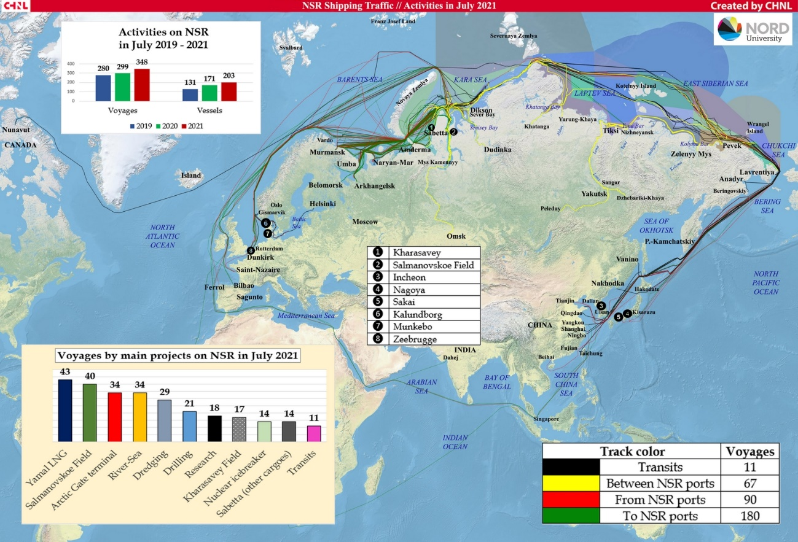

Fig. … Routes of vessels moving to and from terminals (existing and under construction) Ob Estuary in July 2021.

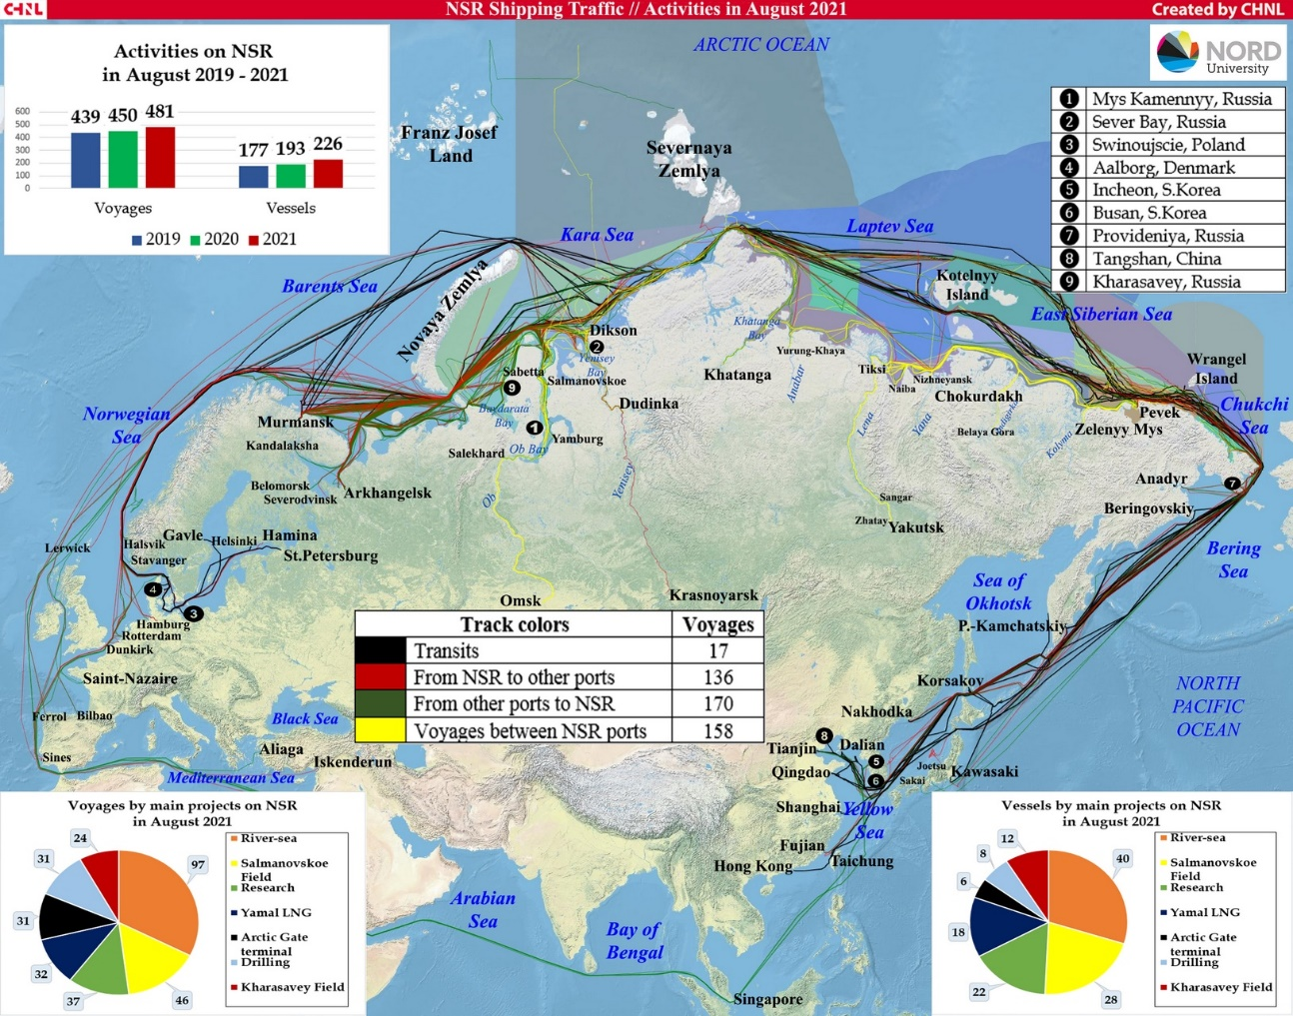

Fig. … Routes of vessels moving to and from terminals (existing and under construction) Ob Estuary in August 2021.

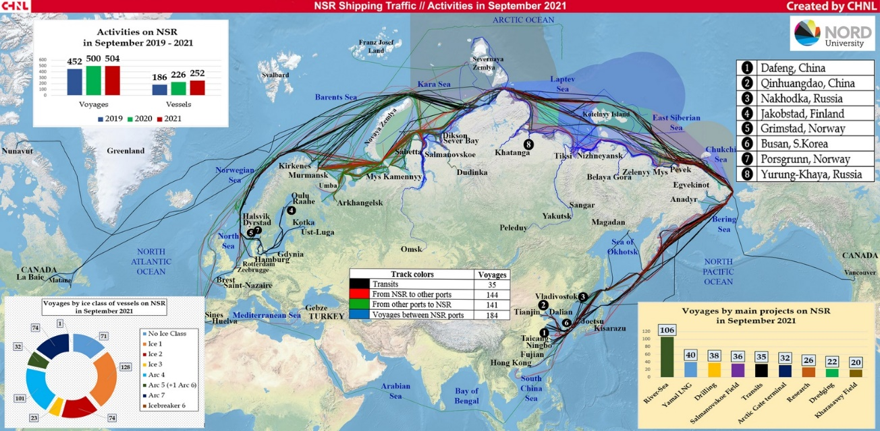

Fig. … Routes of vessels moving to and from terminals (existing and under construction) Ob Estuary in September 2021.

More than half of the export shipments in July and August 2021 went eastward – to China, Japan and South Korea (8 shipments out of 14), and 6 vessels went to Europe – to the Netherlands, Spain, Portugal and France (<https://arctic-lio.com/>). In 2020 main destination of LNG and gas condensate were European ports: Belgium (62 voyages), France (58), Netherlands (26), Spain (30), UK (22). There were 25 voyages in China.

The most likely rout for NIS transfer is the western one, because all destination ports in Asia are situated further south than European ones. The most probable candidate are Netherlands as the most northward location. Therefore, we should concentrate on organisms, which are documented as numerous and spreading their range in the northern Europe. We should keep in mind the increase of voyage number during the last three years and very probable preservation of this trend in future, which means increase of NIS load in the area of interest.

## Источники информации и их анализ

Information on native species of benthos and zooplankton was taken from (+++++ **ref. for previous report**). Native species involved in the analysis included those forms that were determined to species level (or in cases of presumed cryptic species, to genus). We considered only those species which were found and abundant in benthic and plankton surveys in the estuarine portion of the water area (at stations south of 73 degrees N). Pure marine species, represented mainly in the northern part of the water area, were not included in the consideration.

The *Invasive Species in Russia* database (<http://www.sevin.ru/top100worst/index.html>) was used to identify PNIS among benthic forms. Additionally, species mentioned as potential invasive species in Arctic waters (Goldshmit et al. 2020) were included in the analysis.

To identify PNIS among planktonic forms +++++

### Analysis of geographic distribution of hydrobionts

In the summarized list of benthic and planktonic species (164 вида), each of them was labeled as “Native” or “PNIS”. Next, for each species, the Global Biodiversity Information Facility database (<https://www.gbif.org/>) was queried to find the geographic localities where the species was occured. Only unique combinations of latitude and longitude were considered. A Geographic Dataset (GDS) was generated from these queries ( 266251 unique localities were included).

The GDS was used to analyze the latitudinal distribution of species. This analysis compared the latitudinal range limits of native species and PNIS. This analysis is designed to screen out those PNIS whose distribution centers are far from the geographic boundaries of the analyzed water area. The following values were calculated from the GDS and considered as biogeographic characteristics of the species.

- the median of latitude values. It is assumed that this value characterizes the “core” of the latitudinal range.

- Maximum value of latitude, at which the species was occured

- value of 2.5% quantile of latitude

- value of 97.5% of the quantile of latitude

- the ratio of the number of localities with latitude above the Arctic Circle to the total number of encounters. It is assumed that the higher this value, the more likely this species is found in the Polar region.

- the value of asymmetry in the distribution of latitude values. It is assumed that the more asymmetric the distribution, the more pronounced is the tendency of displacement of the species from the range.

- value similar to the previous one. It is the ratio of the distance from the median of latitude to Q_low to the distance from the median to Q_up. The logathmic transformation was applied to make the values distributed in range between 0 and 1 more pronounced.

$$Asymmetry=ln(\frac{|Q_{up}−M|}{|Q_{low}−M|})$$

The matrix of these variables was used in principal component analysis (PCA). The score of PC1 was used for a general assessment of latitudal species distribution.

### Assessment of environmental parameters

For all species included in the analysis (Native and PNIS), salinity and temperature values at their occurence (GBIF) points were estimated. Bio-ORACLE GIS (<https://bio-oracle.org/>; Tyberghein et al. 2021; Assis et al. 2017) was used to estimate hydrological parameters in marine areas. Sea water salinity (mean at mean depth) and sea water temperature (mean at mean depth) were extracted from this GIS for each occurence point. Because some of the geographic locations of the species occurence were in freshwater areas, temperature data were additionally searched using EarthEnv GIS (<http://www.earthenv.org/streams>; Domisch et al., 2015). For the locations whose parameters were estimated using the EarthEnv GIS, the salinity value was assumed to be zero.

### Statistic analysis

All data processing was performed with functions of R statistical programming language (R Core Team, 20++).

The queries for GBIF were performed with package “spocc” (Scott Chamberlain, 2021). The verification of taxonomic characteristics of species was processed with the package “worms” (Holstein, 2018) retriving the information from WoRMS data base (<https://www.marinespecies.org/>).

Principal component analysis was performed with the package “vegan” (Oksanen et al. 2020)

# Assessment Results

## Short introduction to hydrological conditions in the Ob estuary

The hydrological model INMOM was a source of information to describe hydrological conditions in the Ob estuary. The model made it possible to consider values of two key hydrological parameters (water temperature and salinity) in areas located in the vicinity of the currently operating port, “Sabetta”, and the port under design, Terminal “Utrenny” (Fig ++).

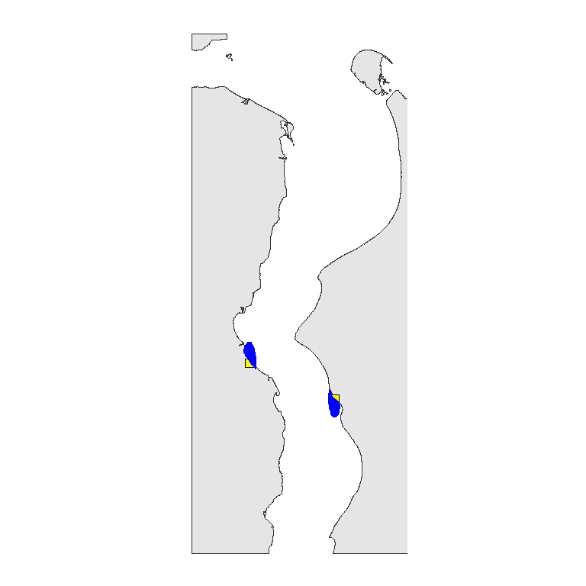

Figure ++. Area of ports and position of hydrological data assessment lovalities

Temperature and salinity in the area experience seasonal fluctuations (Fig. ++). The highest salinity is observed in spring, when the saline water tongue goes far upstream.

Water temperature values increase as the distance from the mouth of the Gulf of Ob upstream increases (Fig. ++).

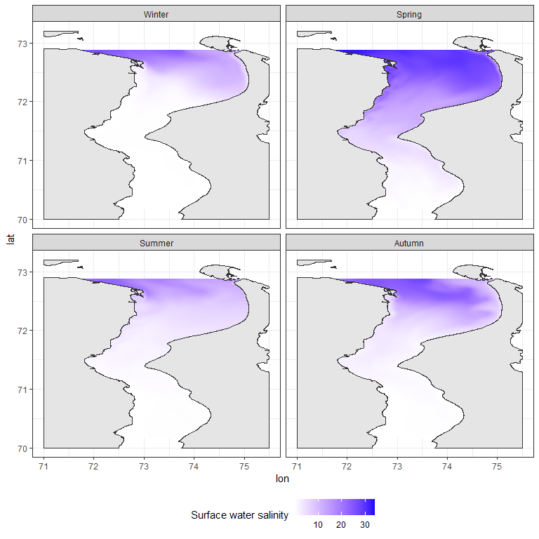

Figure ++. Salinity in Ob estuary in four seasons

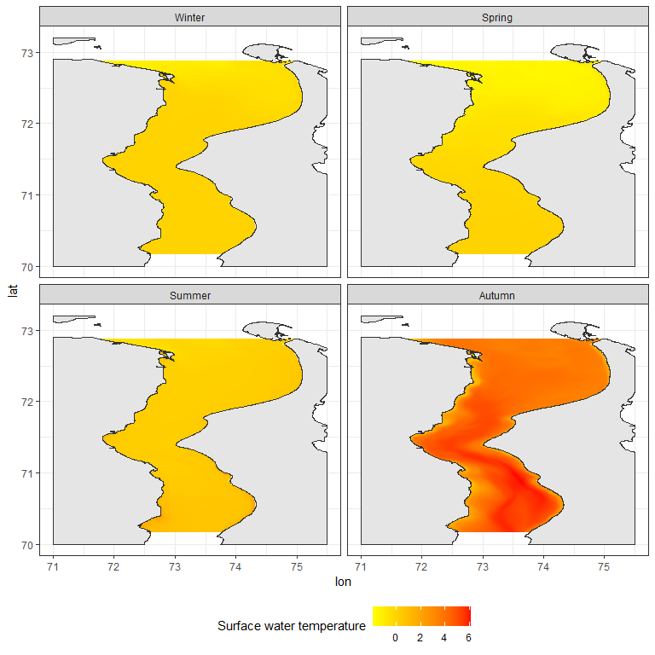

Figure ++. Surface temperature in Ob estuary in four seasons

Model predictions were made for 796 points located in the areas adjacent to the ports (Fig. ++). For these points, salinity and water temperature values were calculated for each day of the calendar year for five depth levels (0, 5, 10, 15, and 20 meters). In the further analysis, the average value of salinity and temperature calculated for each point was taken.

T-S diagrams (Fig. ++) show that cold, saline water is present in the port area in winter and spring. Salinity during this period varies within 0, 13 ppm and temperature within -0.5, 1.6 degrees.

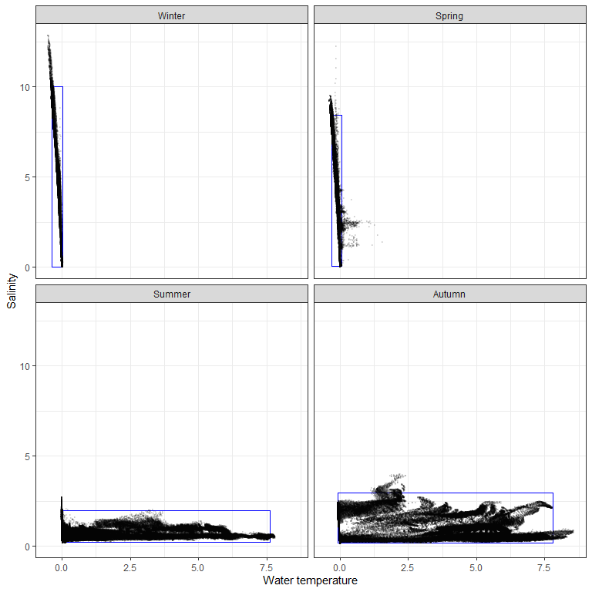

Figure ++. T-S diagram reflecting limits of salinity and tempereature variation in the area of ports.

During the summer and fall salinity is low but there is considerable warming of the water in these seasons. During these periods salinity varies within 0.1, 4 promille and temperature: -0.1, 8.6 degrees.

To describe the boundaries of the “ecological license” of the biotope (the term explanation see in Ozerskii, 2011) that could potentially be inhabited by NIS, the salinity and temperature limits in the water area adjacent to the port areas were calculated as values of 0.5% and 99.5% quantiles of each of the parameters. In the Figure ++, these limits are indicated by rectangles.

The boundary of ecological license is the hydrological conditions that can be inhabited by PNIS. The port area seems to be the most likely areas for NIS invasion (++++ **reference**). However, according to climate change projections (<https://interactive-atlas.ipcc.ch/>), ocean surface temperatures will gradually increase in the Russian Arctic region (about 2 degrees per century. **Проверить**). Hence, the boundaries of the ecological license along the temperature axis will shift towards higher temperatures, which will expand the possibility of NIS invasion in the future.

**Conclusion**

The warmest water mass is present in the water area during the autumn period. Thus this is a season that should be considered as the most dangerous in terms of the probability of introducing species from temperate latitudes.

It should be emphasized that any antropgenic temperature increase will increase the likelihood of NIS invasion.

## Biogeographical analysis of potential NIS

Using available datasets we found rather large amount PNIS between benthic animals but only few one between zooplankton (Table ++). However controversy situation was found between native forms.

Table ++. Number of native and potentialy Non-indigenous speciesinvolved in the biogeografical analysis for benthic and planktonic animals.

|  |  |  |
| --- | --- | --- |
| Group | Native | PNIS |
| Benthos | 13 | 49 |
| Plankton | 95 | 7 |

The first principal component describing 81.8% of the total variation in species biogeographic characteristics shows a high negative correlation with the southern species distribution boundary ($Q_{low}$), median latitude ($Median_{lat}$) and northern species distribution boundary ($Q_{up}$). Thus, PC1 values can be interpreted as a latitudinal gradient in species distribution. Smaller values of PC1 correspond to higher latitudes.

It can be observed that native forms of benthos have a slightly more northern distribution than native planktonic forms. The latitudinal core of distribution of potential NIS involved in the analysis is shifted southerly in both benthic and planktonic potential invaders.

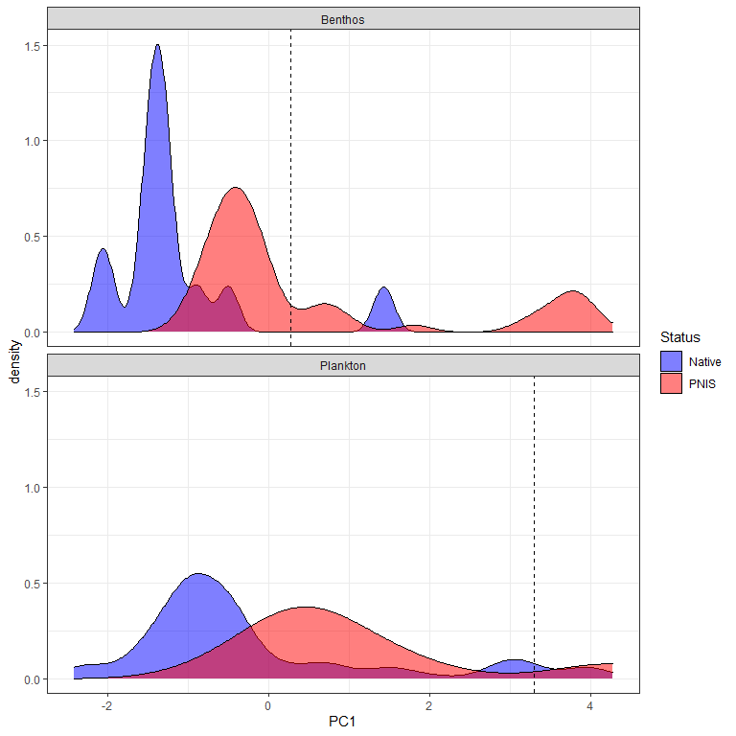

If we consider the value of the 95% quantile of PC1 as the southern boundary of native species distribution (vertical lines in Fig. ++), then among benthic species 49 falls into number of species whose ranges are close to native species, but among planktonic only 7 species distributed closely to with native zooplankton species. Biogeographic characteristics of potential NIS are given in Table ++.

For all species included in the analysis (both Native and PNIS), salinity and temperature values at their occurence localities, taken from the GBIF database, were estimated. Bio-ORACLE GIS (Tyberghein et al. 2021; Assis et al. 2017) was used to estimate hydrological parameters in marine areas. Sea water salinity (mean at mean depth) and sea water temperature (mean at mean depth) were extracted from this GIS for each encounter point. Because some of the geographic locations of species were in freshwater areas, temperature data were additionally searched using EarthEnv GIS (Domisch et al., 2015). The key season of potential NIS invasion is autumn (see above), so the average temperature value during the autumn period was taken to estimate the temperature at a given location. For locations whose parameters were estimated using EarthEnv GIS, the salinity value was assumed to be zero.

The area of maximum concentration of points corresponding to native species of benthos organisms agrees very well with the boundaries of the ecological license of the Ob estuary. Salinity values in the range of 0-10 ppm and 0-10 degrees can be considered as conditional niche boundaries for native benthos species. In the case of native plankton species some points also presented inside these boundaries. However, the maximum concentration of points, although falling within the cold-water range (less than 10 degrees), falls within ranges of the normal oceanic salinity.

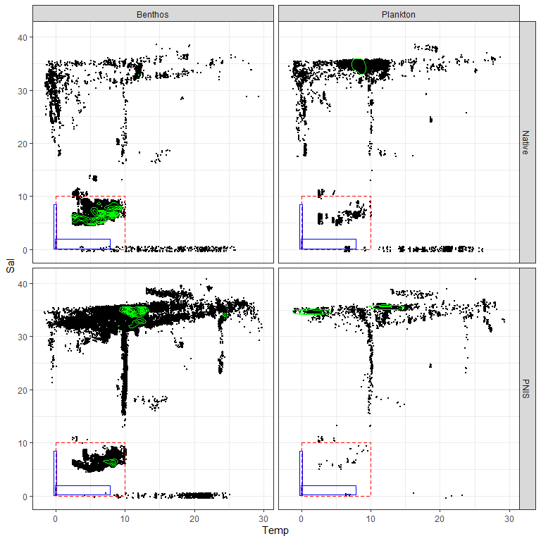

Figure ++. +++++

To quantify the probability of PNIS colonization in the conditions of the Gulf of Ob, we introduced the value $P_{inv}$. To calculate this estimate, we calculated the number of locations obtained from the GBIF database for which the salinity-temperature conditions approximately corresponded to the ecological license of the Gulf of Ob (Salinity:0-10 ppm, Temperature 0-10 degrees). This value was divided by the total number of locations (for this species in the GBIF database) for which salinity and temperature were assessed. Values of these values are given in Table ++.

Table ++. Potencial NIS for the Ob estuary ecosystem. Biogeographical characteristics: Q_low - 2.5% quantile of latitude, Median_lat - median of latitude, Q_up - 97.5% quantile of latitude. N_occ_in_env - number of references in GBIF with environmental parameters close to those in the Ob estuary. N_occ_total - total number of references in GBIF with salinity and temperature assessed.

|  |  |  |  |  |  |  |  |  |
| --- | --- | --- | --- | --- | --- | --- | --- | --- |
| Status | species | Group | Q_low | Median_lat | Q_up | N_occ_in_env | N_occ_total | P_inv |
| Native | Bosmina kessleri | Plankton | 61.8 | 62.0 | 62.0 | 3 | 3 | 1.000 |
| Native | Monoporeia affinis | Benthos | 56.0 | 60.2 | 65.7 | 8461 | 8461 | 0.983 |
| Native | Saduria entomon | Benthos | 55.8 | 60.4 | 69.6 | 6351 | 6351 | 0.954 |
| Native | Halicryptus spinulosus | Benthos | 55.2 | 58.3 | 60.6 | 3315 | 3315 | 0.950 |
| Native | Marenzelleria | Benthos | 39.2 | 59.2 | 64.6 | 7087 | 7087 | 0.940 |
| Native | Mysis relicta | Benthos | 45.1 | 62.9 | 70.1 | 666 | 666 | 0.811 |
| Native | Pontoporeia femorata | Benthos | 54.8 | 58.7 | 72.0 | 1739 | 1739 | 0.811 |
| Native | Bosmina coregoni | Plankton | 53.7 | 63.5 | 65.7 | 324 | 324 | 0.731 |
| Native | Daphnia cristata | Plankton | 58.7 | 60.6 | 69.4 | 215 | 215 | 0.693 |
| Native | Keratella quadrata | Plankton | 37.3 | 61.8 | 65.7 | 626 | 626 | 0.657 |
| Native | Keratella cochlearis | Plankton | -0.5 | 61.8 | 65.7 | 619 | 619 | 0.635 |
| Native | Bosmina maritima | Plankton | 55.0 | 57.3 | 58.8 | 7 | 7 | 0.571 |
| Native | Limnosida frontosa | Plankton | 55.3 | 59.7 | 62.0 | 11 | 11 | 0.545 |
| Native | Limnocalanus macrurus | Plankton | 59.6 | 63.5 | 74.4 | 732 | 732 | 0.518 |
| Native | Daphnia cucullata | Plankton | 49.7 | 53.0 | 65.2 | 85 | 85 | 0.435 |
| Native | Eurytemora affinis | Plankton | 30.9 | 51.3 | 65.7 | 217 | 217 | 0.387 |
| Native | Thermocyclops oithonoides | Plankton | 51.0 | 59.4 | 65.3 | 101 | 101 | 0.386 |
| Native | Kellicottia longispina | Plankton | 33.6 | 52.1 | 64.3 | 73 | 73 | 0.274 |
| Native | Trichocerca porcellus | Plankton | 18.8 | 47.5 | 62.0 | 11 | 11 | 0.273 |
| Native | Notholca caudata | Plankton | 45.8 | 46.1 | 58.1 | 4 | 4 | 0.250 |
| Native | Cyclops strenuus | Plankton | 40.1 | 51.2 | 61.2 | 14 | 14 | 0.214 |
| Native | Biapertura affinis | Plankton | -32.2 | 19.8 | 56.9 | 5 | 5 | 0.200 |
| Native | Eurytemora hirundoides | Plankton | 40.6 | 54.1 | 59.4 | 10 | 10 | 0.200 |
| Native | Trichocerca capucina | Plankton | 18.3 | 48.9 | 62.0 | 15 | 15 | 0.200 |
| Native | Moina macrocopa | Plankton | 19.2 | 50.7 | 61.8 | 22 | 22 | 0.182 |
| Native | Eurycercus lamellatus | Plankton | 50.6 | 60.0 | 69.6 | 339 | 339 | 0.177 |
| Native | Notholca acuminata | Plankton | 43.5 | 51.9 | 62.0 | 17 | 17 | 0.176 |
| Native | Leptodora kindti | Plankton | 50.1 | 59.7 | 68.2 | 116 | 116 | 0.147 |
| Native | Synchaeta pectinata | Plankton | -41.8 | 45.4 | 62.0 | 21 | 21 | 0.143 |
| Native | Podon leuckarti | Plankton | 33.0 | 62.7 | 70.6 | 226 | 226 | 0.142 |
| Native | Sida crystallina | Plankton | 50.6 | 59.8 | 69.2 | 281 | 281 | 0.132 |
| Native | Diacyclops bisetosus | Plankton | 38.9 | 51.1 | 60.0 | 8 | 8 | 0.125 |
| Native | Limnodrilus hoffmeisteri | Benthos | 4.7 | 51.9 | 60.5 | 1411 | 1411 | 0.125 |
| Native | Paracyclops fimbriatus | Plankton | -26.1 | 59.6 | 69.1 | 36 | 36 | 0.111 |
| Native | Euchlanis dilatata | Plankton | -27.9 | 32.9 | 61.9 | 28 | 28 | 0.107 |
| Native | Mesocyclops leuckarti | Plankton | 50.0 | 59.7 | 64.7 | 147 | 147 | 0.102 |
| Native | Bosmina longirostris | Plankton | -0.6 | 52.2 | 65.7 | 192 | 192 | 0.099 |
| Native | Brachionus calyciflorus | Plankton | -25.7 | 45.3 | 62.0 | 74 | 74 | 0.095 |
| Native | Megacyclops viridis | Plankton | 42.1 | 59.6 | 69.6 | 74 | 74 | 0.095 |
| Native | Eurytemora lacustris | Plankton | 51.4 | 52.2 | 60.1 | 11 | 11 | 0.091 |
| Native | Polyarthra dolichoptera | Plankton | -25.7 | 51.7 | 61.8 | 34 | 34 | 0.088 |
| Native | Diacyclops bicuspidatus | Plankton | 40.1 | 51.3 | 60.9 | 23 | 23 | 0.087 |
| Native | Alona quadrangularis | Plankton | 43.8 | 52.6 | 69.2 | 58 | 58 | 0.086 |
| Native | Heterocope appendiculata | Plankton | 59.3 | 62.6 | 71.9 | 47 | 47 | 0.064 |
| Native | Asplanchna priodonta | Plankton | 42.6 | 54.3 | 69.6 | 97 | 97 | 0.062 |
| Native | Acanthocyclops vernalis | Plankton | 24.6 | 58.8 | 69.5 | 50 | 50 | 0.060 |
| Native | Filinia longiseta | Plankton | -24.6 | 45.9 | 63.4 | 73 | 73 | 0.055 |
| Native | Brachionus angularis | Plankton | -1.4 | 38.8 | 53.3 | 74 | 74 | 0.054 |
| Native | Daphnia galeata | Plankton | 42.5 | 60.1 | 69.5 | 162 | 162 | 0.049 |
| Native | Daphnia pulex | Plankton | 19.4 | 51.2 | 74.3 | 129 | 129 | 0.047 |
| Native | Ceriodaphnia pulchella | Plankton | 49.7 | 53.2 | 68.9 | 92 | 92 | 0.033 |
| Native | Bosmina longispina | Plankton | 58.1 | 60.6 | 69.7 | 143 | 143 | 0.021 |
| Native | Bythotrephes longimanus | Plankton | 42.4 | 60.1 | 69.3 | 144 | 144 | 0.021 |
| Native | Eudiaptomus gracilis | Plankton | 51.1 | 58.8 | 69.5 | 203 | 203 | 0.020 |
| Native | Macrocyclops albidus | Plankton | 18.1 | 59.9 | 69.7 | 346 | 346 | 0.020 |
| Native | Ceriodaphnia reticulata | Plankton | 9.3 | 51.3 | 61.5 | 57 | 57 | 0.018 |
| Native | Chydorus sphaericus | Plankton | 35.9 | 58.6 | 69.2 | 495 | 495 | 0.018 |
| Native | Eucyclops serrulatus | Plankton | 39.3 | 60.3 | 69.9 | 356 | 356 | 0.017 |
| Native | Daphnia longispina | Plankton | 0.3 | 59.8 | 69.1 | 265 | 265 | 0.015 |
| Native | Eudiaptomus graciloides | Plankton | 51.0 | 69.0 | 70.6 | 131 | 131 | 0.015 |
| Native | Acroperus harpae | Plankton | 50.0 | 60.1 | 69.8 | 398 | 398 | 0.013 |
| Native | Alona affinis | Plankton | 43.3 | 60.1 | 69.8 | 426 | 426 | 0.012 |
| Native | Diaphanosoma brachyurum | Plankton | 50.0 | 59.3 | 68.3 | 274 | 274 | 0.011 |
| Native | Ophryoxus gracilis | Plankton | 58.2 | 61.9 | 69.7 | 178 | 178 | 0.011 |
| Native | Cyclops abyssorum | Plankton | 47.2 | 60.6 | 70.1 | 102 | 102 | 0.010 |
| Native | Holopedium gibberum | Plankton | 41.9 | 61.3 | 69.6 | 245 | 245 | 0.008 |
| Native | Temora longicornis | Plankton | 41.1 | 54.2 | 63.7 | 2124 | 2124 | 0.004 |
| Native | Acanthocyclops capillatus | Plankton | 51.0 | 59.7 | 69.7 | 0 | 14 | 0.000 |
| Native | Ampharete vega | Benthos | 66.3 | 69.7 | 77.3 | 0 | 49 | 0.000 |
| Native | Bosmina cornuta | Plankton | 51.4 | 53.1 | 53.2 | 0 | 10 | 0.000 |
| Native | Bosmina crassicornis | Plankton | 53.3 | 53.4 | 53.5 | NA | NA | NA |
| Native | Bosmina longicornis | Plankton | 53.4 | 53.5 | 53.5 | NA | NA | NA |
| Native | Brachionus plicatilis | Plankton | -34.4 | 21.8 | 52.4 | 0 | 26 | 0.000 |
| Native | Bythotrephes cederstroemi | Plankton | 47.9 | 59.3 | 59.7 | NA | NA | NA |
| Native | Cyclops albidus | Plankton | 43.6 | 49.9 | 54.6 | 0 | 1 | 0.000 |
| Native | Cyclops bicuspidatus | Plankton | 42.2 | 69.4 | 69.6 | 0 | 9 | 0.000 |
| Native | Cyclops fimbriatus | Plankton | 49.6 | 49.6 | 49.8 | NA | NA | NA |
| Native | Cyclops insignis | Plankton | 50.2 | 60.2 | 63.2 | 0 | 2 | 0.000 |
| Native | Cyclops kolensis | Plankton | 51.9 | 55.8 | 72.4 | 0 | 1 | 0.000 |
| Native | Cyclops lacustris | Plankton | 59.2 | 59.7 | 60.8 | NA | NA | NA |
| Native | Cyclops leuckarti | Plankton | -15.4 | 49.9 | 50.1 | NA | NA | NA |
| Native | Cyclops scutifer | Plankton | 58.3 | 61.3 | 69.7 | 0 | 113 | 0.000 |
| Native | Cyclops serrulatus | Plankton | 43.1 | 49.8 | 50.7 | NA | NA | NA |
| Native | Cyclops vernalis | Plankton | 42.2 | 53.2 | 69.7 | 0 | 19 | 0.000 |
| Native | Cyclops vicinus | Plankton | 37.9 | 51.4 | 63.4 | 0 | 33 | 0.000 |
| Native | Daphnia hyalina | Plankton | 50.6 | 52.8 | 64.3 | 0 | 54 | 0.000 |
| Native | Daphnia longiremis | Plankton | 44.7 | 59.4 | 69.7 | 0 | 16 | 0.000 |
| Native | Diaphanosoma leuchtenbergianum | Plankton | -25.4 | 42.4 | 52.4 | 0 | 1 | 0.000 |
| Native | Diaptomus glacialis | Plankton | 53.5 | 72.1 | 74.3 | 0 | 8 | 0.000 |
| Native | Diaptomus gracilis | Plankton | 44.8 | 45.1 | 54.9 | 0 | 4 | 0.000 |
| Native | Drepanopus bungei | Plankton | 69.6 | 73.6 | 82.5 | 0 | 223 | 0.000 |
| Native | Eurycercus glacialis | Plankton | 53.9 | 61.4 | 70.1 | 0 | 9 | 0.000 |
| Native | Eurytemora gracilis | Plankton | 70.5 | 72.1 | 73.7 | 0 | 6 | 0.000 |
| Native | Gammaracanthus | Benthos | 49.0 | 69.5 | 80.1 | 0 | 129 | 0.000 |
| Native | Gammaracanthus lacustris | Benthos | 55.1 | 60.8 | 80.3 | 0 | 2 | 0.000 |
| Native | Heterocope borealis | Plankton | 65.7 | 69.9 | 70.6 | 0 | 4 | 0.000 |
| Native | Limnocalanus grimaldii | Plankton | 68.2 | 70.6 | 71.7 | 0 | 4 | 0.000 |
| Native | Megacyclops gigas | Plankton | 51.0 | 61.5 | 70.1 | 0 | 110 | 0.000 |
| Native | Mesochra lilljeborgii | Plankton | 28.7 | 57.6 | 58.8 | 0 | 5 | 0.000 |
| Native | Microcyclops varicans | Plankton | -37.3 | 11.8 | 59.9 | 0 | 6 | 0.000 |
| Native | Mysis oculata | Benthos | 53.7 | 71.1 | 79.4 | 0 | 228 | 0.000 |
| Native | Saduria sabini | Benthos | 53.5 | 70.2 | 78.7 | 0 | 157 | 0.000 |
| Native | Saduria sibirica | Benthos | 64.3 | 70.1 | 76.5 | 0 | 25 | 0.000 |
| Native | Senecella calanoides | Plankton | 46.1 | 47.4 | 70.0 | 0 | 1 | 0.000 |
| Native | Senecella siberica | Plankton | 71.3 | 72.2 | 73.0 | 0 | 3 | 0.000 |
| Native | Simocephalus vetulus | Plankton | -27.8 | 52.6 | 68.9 | 0 | 351 | 0.000 |
| Native | Synchaeta grandis | Plankton | 46.1 | 60.2 | 60.6 | 0 | 3 | 0.000 |
| Native | Thermocyclops dybowskii | Plankton | 50.5 | 51.2 | 60.4 | 0 | 2 | 0.000 |
| PNIS | Amphibalanus improvisus | Benthos | 35.4 | 59.2 | 63.5 | 7698 | 7698 | 0.862 |
| PNIS | Euilyodrilus heuscheri | Benthos | 43.1 | 47.6 | 60.0 | 10 | 10 | 0.700 |
| PNIS | Cercopagis pengoi | Plankton | 41.8 | 43.7 | 63.5 | 16 | 16 | 0.688 |
| PNIS | Paramysis lacustris | Benthos | 44.2 | 46.5 | 55.4 | 3 | 3 | 0.667 |
| PNIS | Paramysis intermedia | Benthos | 45.3 | 46.9 | 56.5 | 2 | 2 | 0.500 |
| PNIS | Gammarus tigrinus | Benthos | 51.1 | 52.5 | 59.0 | 2687 | 2687 | 0.453 |
| PNIS | Euilyodrilus vejdovskyi | Benthos | 43.4 | 47.1 | 56.2 | 9 | 9 | 0.444 |
| PNIS | Dreissena polymorpha | Benthos | 37.9 | 49.8 | 59.2 | 1257 | 1257 | 0.428 |
| PNIS | Rhithropanopeus harrisii | Benthos | 18.8 | 49.5 | 60.2 | 506 | 506 | 0.427 |
| PNIS | Pontogammarus robustoides | Benthos | 45.7 | 59.4 | 59.4 | 15 | 15 | 0.400 |
| PNIS | Potamopyrgus antipodarum | Benthos | -41.4 | 52.4 | 59.7 | 7796 | 7796 | 0.342 |
| PNIS | Potamothrix heuscheri | Benthos | 38.0 | 51.9 | 58.5 | 50 | 50 | 0.320 |
| PNIS | Mya arenaria | Benthos | 37.8 | 54.4 | 63.0 | 3307 | 3307 | 0.315 |
| PNIS | Eriocheir sinensis | Benthos | 37.7 | 51.2 | 58.6 | 611 | 611 | 0.195 |
| PNIS | Potamothrix vejdovskyi | Benthos | 41.9 | 46.4 | 58.4 | 37 | 37 | 0.135 |
| PNIS | Ilyodrilus heuscheri | Benthos | 45.8 | 46.7 | 53.1 | 8 | 8 | 0.125 |
| PNIS | Gmelinoides fasciatus | Benthos | 51.9 | 59.8 | 62.8 | 19 | 19 | 0.105 |
| PNIS | Acanthocyclops robustus | Plankton | 19.8 | 59.0 | 69.3 | 119 | 119 | 0.067 |
| PNIS | Dikerogammarus haemobaphes | Benthos | 48.7 | 52.3 | 53.9 | 42 | 42 | 0.048 |
| PNIS | Lithoglyphus naticoides | Benthos | 45.6 | 51.2 | 53.2 | 66 | 66 | 0.030 |
| PNIS | Mytilopsis leucophaeata | Benthos | 3.5 | 36.0 | 53.0 | 163 | 163 | 0.025 |
| PNIS | Rangia cuneata | Benthos | 28.1 | 28.4 | 52.4 | 2484 | 2484 | 0.025 |
| PNIS | Acartia tonsa | Plankton | -39.0 | 10.5 | 58.3 | 438 | 438 | 0.018 |
| PNIS | Corbicula fluminalis | Benthos | -32.9 | 51.0 | 52.5 | 83 | 83 | 0.012 |
| PNIS | Mnemiopsis leidyi | Plankton | 26.1 | 51.4 | 59.1 | 708 | 708 | 0.010 |
| PNIS | Dreissena rostriformis | Benthos | 35.3 | 51.7 | 53.0 | 144 | 144 | 0.007 |
| PNIS | Paracalanus parvus | Plankton | 1.8 | 43.5 | 65.2 | 1388 | 1388 | 0.003 |
| PNIS | Physella acuta | Benthos | -39.6 | 50.3 | 53.5 | 464 | 464 | 0.002 |
| PNIS | Platorchestia platensis | Benthos | -24.6 | 40.7 | 56.4 | 505 | 505 | 0.002 |
| PNIS | Carcinus maenas | Benthos | 37.9 | 53.5 | 60.3 | 19385 | 19385 | 0.001 |
| PNIS | Littorina littorea | Benthos | 41.4 | 53.1 | 63.6 | 13461 | 13461 | 0.001 |
| PNIS | Magallana gigas | Benthos | -41.3 | 51.2 | 59.8 | 5050 | 5050 | 0.000 |
| PNIS | Amphibalanus eburneus | Benthos | -23.1 | 29.3 | 42.3 | 0 | 264 | 0.000 |
| PNIS | Anadara kagoshimensis | Benthos | 22.2 | 34.8 | 45.1 | 0 | 222 | 0.000 |
| PNIS | Arcuatula senhousia | Benthos | -38.2 | 35.9 | 39.1 | 0 | 975 | 0.000 |
| PNIS | Beroe ovata | Plankton | 26.7 | 39.0 | 48.6 | 0 | 66 | 0.000 |
| PNIS | Botrylloides violaceus | Benthos | 23.7 | 42.3 | 54.3 | 0 | 974 | 0.000 |
| PNIS | Botryllus schlosseri | Benthos | 34.0 | 51.9 | 59.3 | 0 | 8863 | 0.000 |
| PNIS | Chelicorophium curvispinum | Benthos | 48.7 | 51.4 | 53.9 | 0 | 7 | 0.000 |
| PNIS | Chionoecetes opilio | Benthos | 42.7 | 45.5 | 71.1 | 0 | 3726 | 0.000 |
| PNIS | Ciona intestinalis | Benthos | 33.8 | 55.9 | 63.6 | 0 | 4530 | 0.000 |
| PNIS | Corbicula fluminea | Benthos | 28.8 | 36.7 | 52.0 | 0 | 723 | 0.000 |
| PNIS | Dikerogammarus villosus | Benthos | 47.9 | 51.9 | 53.2 | 0 | 275 | 0.000 |
| PNIS | Haitia acuta | Benthos | 36.8 | 47.1 | 59.9 | 0 | 7 | 0.000 |
| PNIS | Haitia integra | Benthos | 45.6 | 45.6 | 45.8 | NA | NA | NA |
| PNIS | Hypania invalida | Benthos | 50.0 | 51.9 | 53.3 | 0 | 180 | 0.000 |
| PNIS | Ilyodrilus vejdovskyi | Benthos | 44.4 | 46.1 | 52.3 | 0 | 6 | 0.000 |
| PNIS | Molgula manhattensis | Benthos | 31.1 | 51.2 | 57.7 | 0 | 1037 | 0.000 |
| PNIS | Monocorophium acherusicum | Benthos | -38.0 | 37.7 | 58.2 | 0 | 735 | 0.000 |
| PNIS | Obesogammarus crassus | Benthos | 50.8 | 52.0 | 53.8 | 0 | 1 | 0.000 |
| PNIS | Obesogammarus obesus | Benthos | 51.4 | 51.5 | 51.8 | NA | NA | NA |
| PNIS | Oithona davisae | Plankton | 33.4 | 34.7 | 38.1 | 0 | 98 | 0.000 |
| PNIS | Paralithodes camtschaticus | Benthos | 31.2 | 58.3 | 70.6 | 0 | 107 | 0.000 |
| PNIS | Pontogammarus crassus | Benthos | 47.4 | 51.4 | 51.5 | 0 | 1 | 0.000 |
| PNIS | Teredo navalis | Benthos | -35.2 | 40.6 | 58.9 | 0 | 326 | 0.000 |
| PNIS | Tubifex heuscheri | Benthos | 46.0 | 47.3 | 47.4 | 0 | 1 | 0.000 |

To form a short list of PNIS, we removed those species for which the number of locations with the environmental parameters estimated was less than 100. In addition, species for which the estimated probability of invasion (P_inv) was less than 5% were removed. In total, the short list of the most likely invaders included 8 species: Amphibalanus improvisus, Gammarus tigrinus, Dreissena polymorpha, Rhithropanopeus harrisii, Potamopyrgus antipodarum, Mya arenaria, Eriocheir sinensis, Acanthocyclops robustus. Below is a description of them with an assessment of the possible consequences of the introduction of these species into the ecosystem of the Ob estuary.

In addition, we included in the list of taxa discussed below several other forms that were not included in the number of PNIS selected according to formal criteria. We included in this short list the planktonic copepod Acartia bifilosa, and the polychaete Marenzelleria

**Conclusion**

The severe conditions of the Gulf of Ob (an estuary with very cold water) are able to be potentially invaded only by a few hydrobionts. Mostly benthic organisms whose ranges are shifted to the north are expected to be potential invaders. Only few planktonic species are capable of surviving under such severe conditions. Even most native zooplankton species, in their relation to two key hydrological factors (salinity and temperature), are rather related to marine pelagic communities and probably presented in the area by infow of marine waters from the Kara Sea.

## Discription of most expected invasive species

### Acanthocyclops robustus (Sars G.O., 1863)

**Phyllum:**Arthropoda  
**Class:** Hexanauplia  
**Order:** Cyclopoida  
**Family:** Cyclopidae

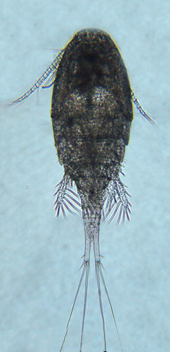

reference for figure

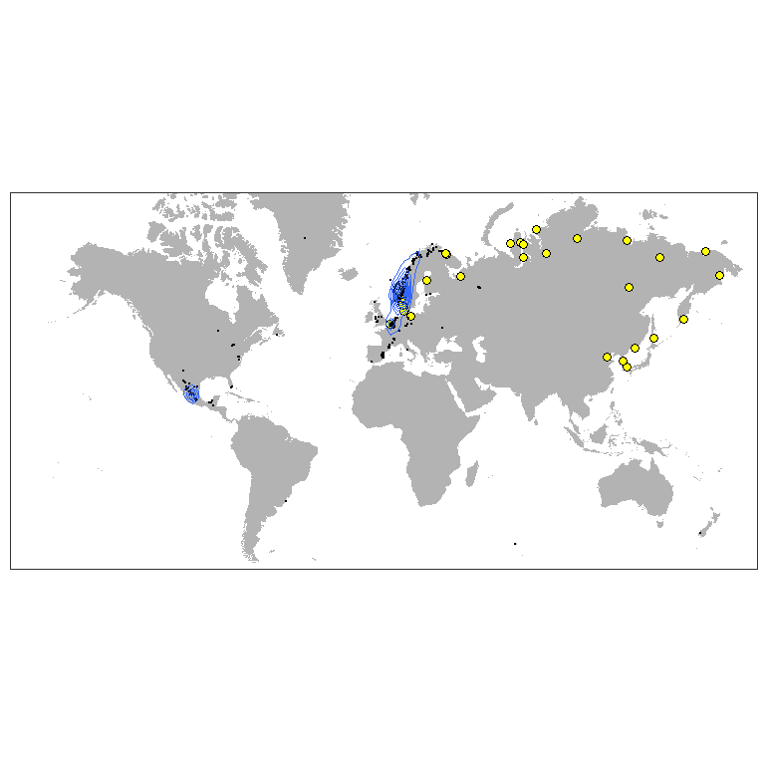

Figure ++. Worldwide distribution of Acanthocyclops robustus accordingly to GBIF.

A. robustus is temperate freshwater species, which is numerous in European lakes, ponds and estuaries (Purasjoki, Viljamaa, 1984; Gonçalves et al., 2012). This species dominates in the freshwater zone of Schelde estuary (Belgium, Netherlands), which is strongly influenced by human activity and characterized by a high load of organic matter as well as toxic substances (Tackx et al., 2004). This species was found to be little affected by environmental gradients, so it must be capable to establish in areas with high variability of environmental parameters, which is typical for Ob Estuary. A. robustus was also regularly documented near Helsinki, in area, highly affected by human activity (Purasjoki, Viljamaa, 1984). A. robustus was documented in waters along Norwegian coast up to Kola peninsula (Fig. +++). This predator, being established, could affect local ecosystem, feeding on local organisms, which do not have behavioral adaptations to this new species. In a perspective, this invasion can lead to significant decrease of populations of prey organisms (Rotifera and small Diplostraca).

### Amphibalanus improvisus (Darwin, 1854)

**Phyllum:**Arthropoda  
**Class:** Thecostraca  
**Order:** Balanomorpha  
**Family:** Balanidae

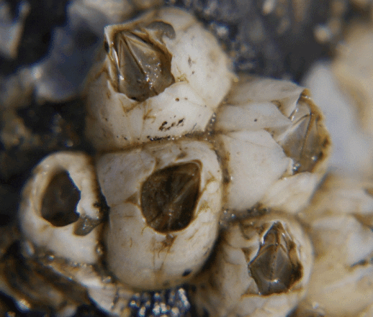

<http://www.sevin.ru/top100worst/priortargets/Arthropods/improvisus.gif>

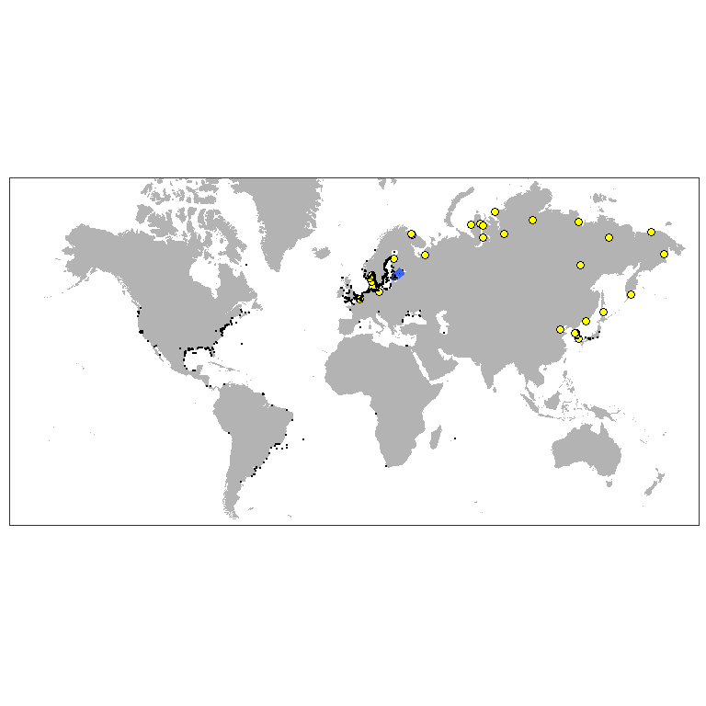

Figure ++. Worldwide distribution of Amphibalanus improvisus accordingly to GBIF.

### Gammarus tigrinus Sexton, 1939

**Phyllum:**Arthropoda  
**Class:** Malacostraca  
**Order:** Amphipoda  
**Family:** Gammaridae

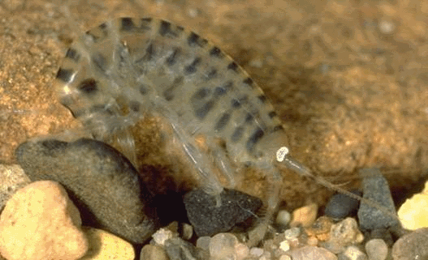

<http://www.sevin.ru/top100worst/priortargets/Arthropods/tigrinus.gif>

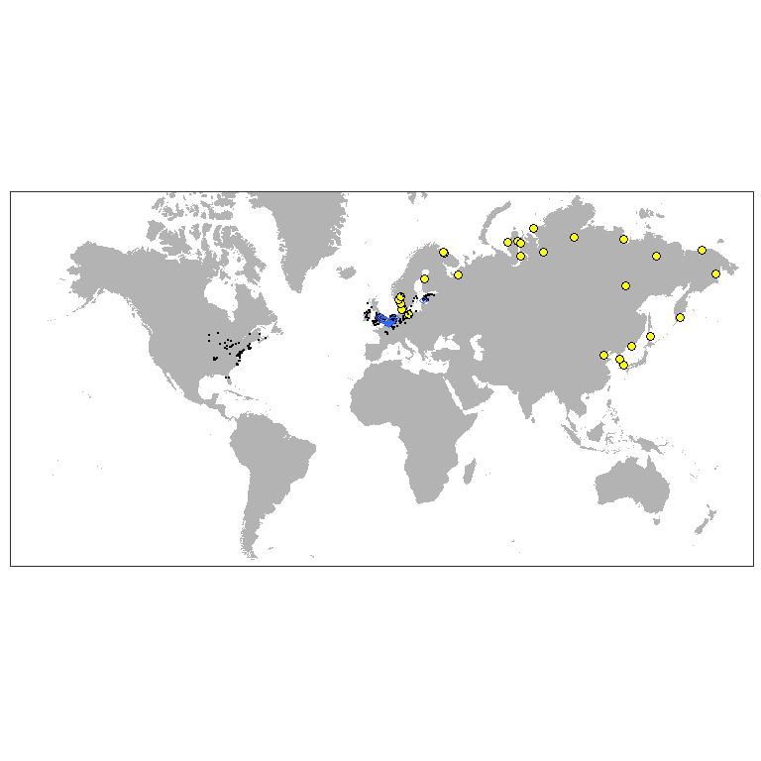

Figure ++. Worldwide distribution of Gammarus tigrinus accordingly to GBIF.

### Rhithropanopeus harrisii (Gould, 1841)

**Phyllum:**Arthropoda  
**Class:** Malacostraca  
**Order:** Decapoda  
**Family:** Panopeidae

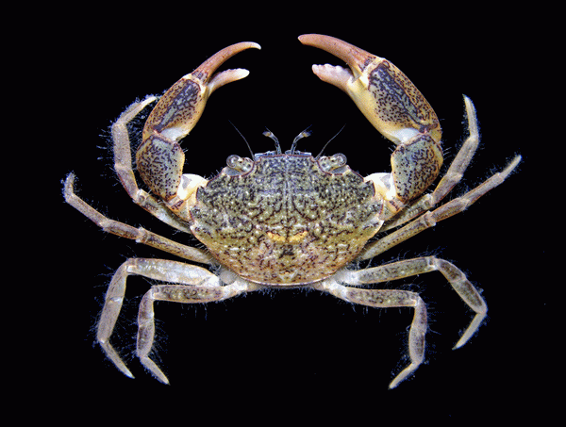

<http://www.sevin.ru/top100worst/priortargets/Arthropods/harrisii.gif>

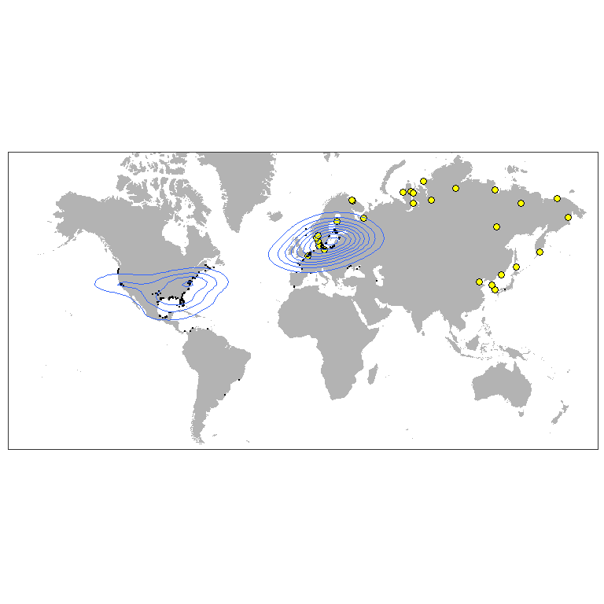

Figure ++. Worldwide distribution of Rhithropanopeus harrisii accordingly to GBIF.

### Eriocheir sinensis H. Milne Edwards, 1853

**Phyllum:**Arthropoda  
**Class:** Malacostraca  
**Order:** Decapoda  
**Family:** Varunidae

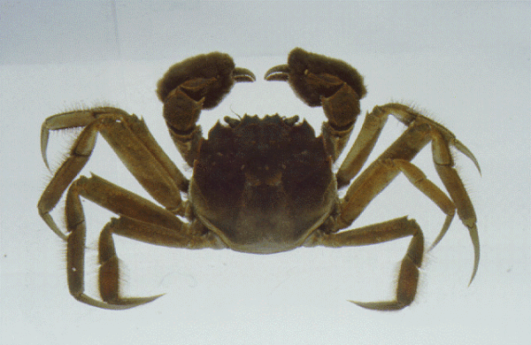

<http://www.sevin.ru/top100worst/priortargets/Arthropods/sinensis.gif>

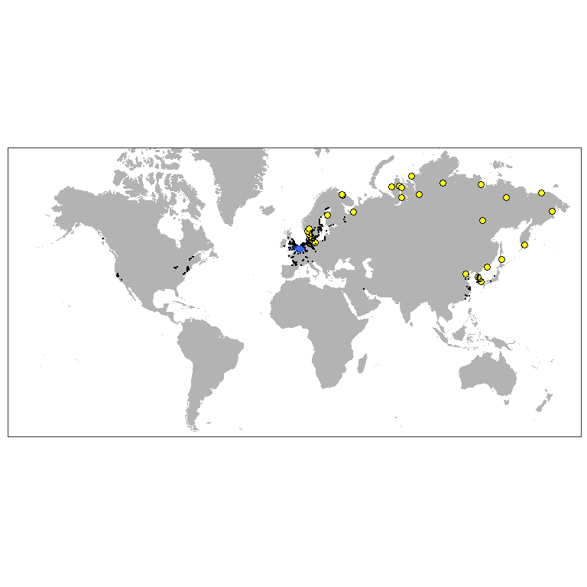

Figure ++. Worldwide distribution of Eriocheir sinensis accordingly to GBIF.

### Dreissena polymorpha (Pallas, 1771)

**Phyllum:**Mollusca  
**Class:** Bivalvia  
**Order:** Myida  
**Family:** Dreissenidae

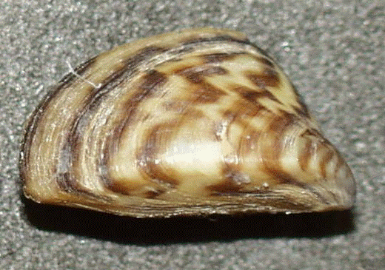

<http://www.sevin.ru/top100worst/priortargets/Mollusca/polymorpha.gif>

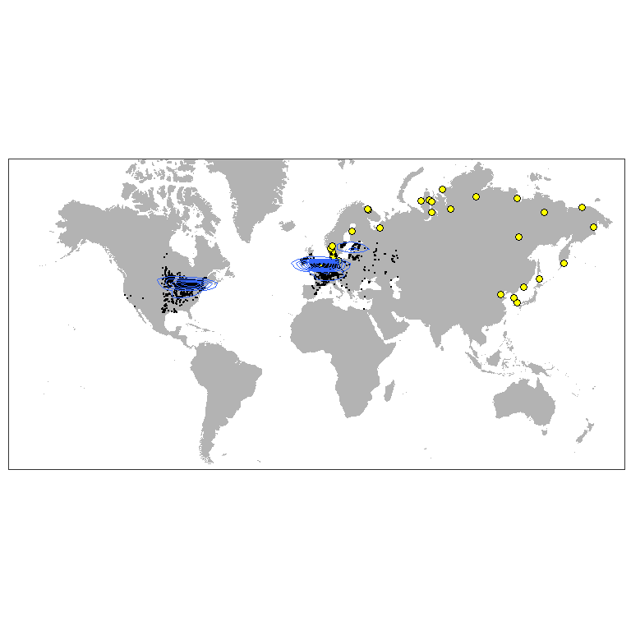

Figure ++. Worldwide distribution of Dreissena polymorpha accordingly to GBIF.

### Mya arenaria Linnaeus, 1758

**Phyllum:**Mollusca  
**Class:** Bivalvia  
**Order:** Myida  
**Family:** Myidae  
`

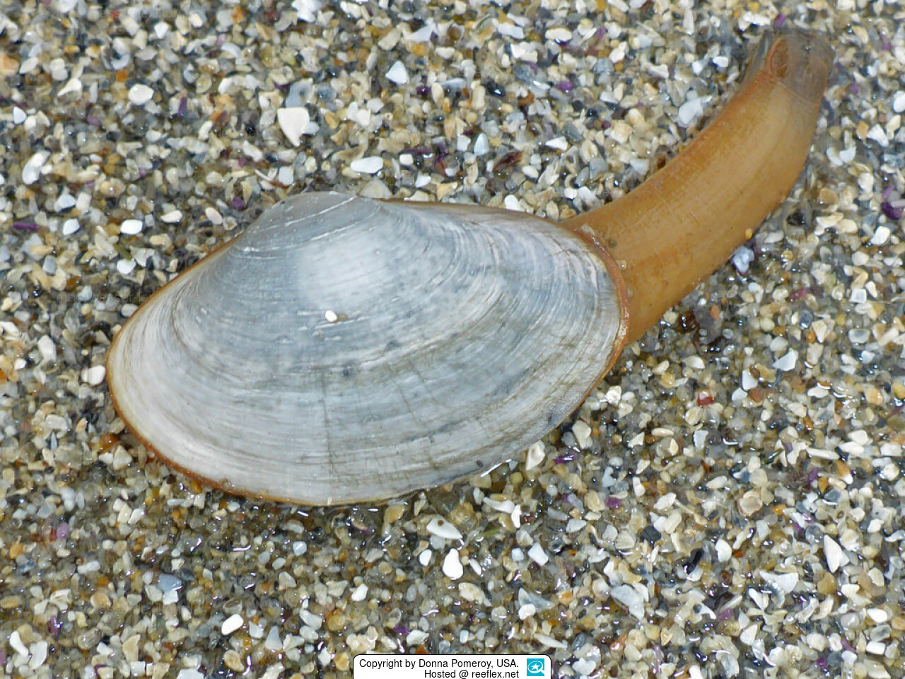

<https://www.meerwasser-lexikon.de/imgHaupt/52049_58ddf591ae3e0.jpg>

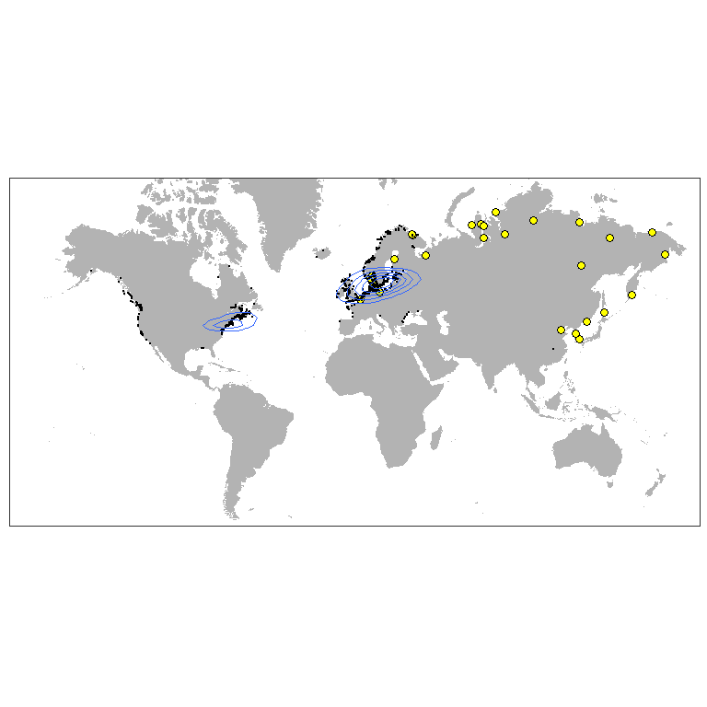

Figure ++. Worldwide distribution of Mya arenaria accordingly to GBIF.

### Potamopyrgus antipodarum (Gray, 1843)

**Phyllum:**Mollusca  
**Class:** Gastropoda  
**Order:** Littorinimorpha  
**Family:** Tateidae

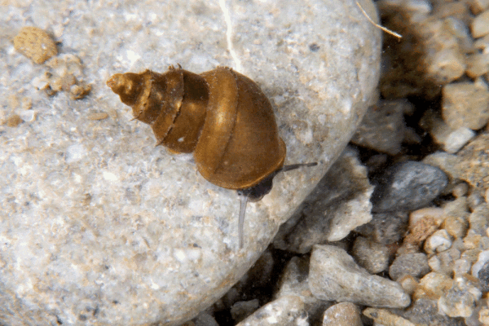

<http://www.sevin.ru/top100worst/priortargets/Mollusca/antipodarum.gif>

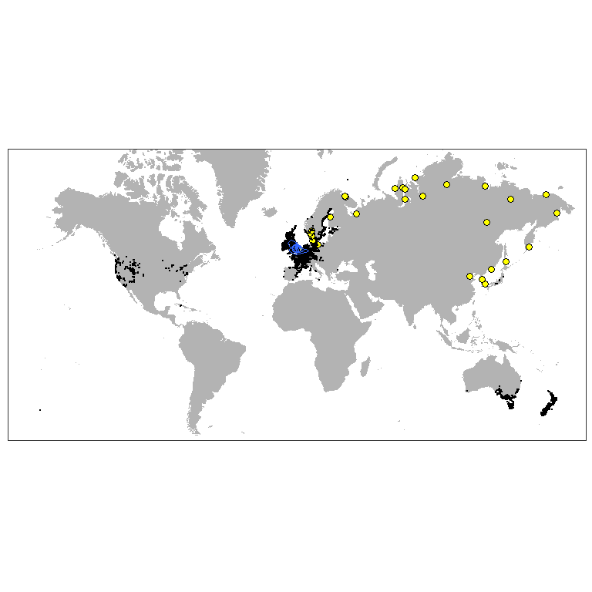

Figure ++. Worldwide distribution of Potamopyrgus antipodarum accordingly to GBIF.

### Marenzelleria Mesnil, 1896

**Phyllum:**Annelida  
**Class:** Polychaeta  
**Order:** Spionida  
**Family:** Spionidae

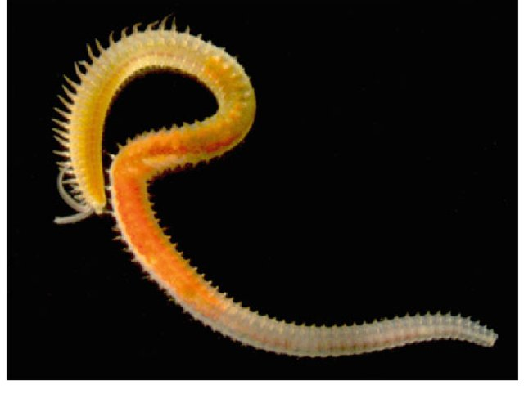

<https://www.researchgate.net/profile/Erik-Bonsdorff/publication/315868278/figure/fig3/AS:555115704979458@1509361305933/Marenzelleria-is-an-example-of-a-highly-successful-non-indigenous-polychaete-genus-in-the_W640.jpg>

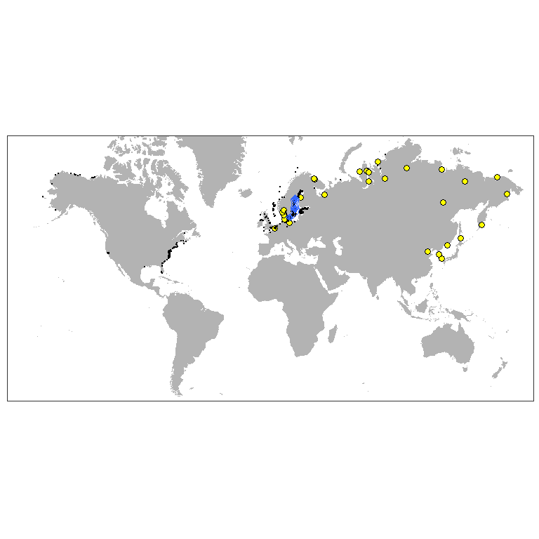

Figure ++. Worldwide distribution of Marenzelleria accordingly to GBIF.